Forensic radiography: An Introduction for Radiologic Technologists
Mark P. Bowes, PhD
Freelance Medical Writer
Portland, Oregon
mpbowes@gmail.com
Keywords: autopsy, computed tomography, PMCT, forensic, postmortem

Learning Objectives
At the conclusion of this activity, learners should be able to:
- Define forensic radiography and describe settings in which it is typically used
- List advantages and limitations of postmortem CT in comparison with traditional autopsy
- Discuss the role of computed tomography (CT) and CT angiography in postmortem tissue examination
- Summarize typical examination findings that might be obtained by forensic radiography in a variety of applications, including assessment of bone fractures, gunshots, bleeding, and traumatic brain injury

Outline
- Introduction
  - Definitions of forensic radiography/forensic imaging
    - Analyzing and interpreting data used in medicolegal cases
  - Most recognized use of forensic radiography is postmortem assessment of cause of death/injury
  - Other uses of forensic radiography
- Radiography as an alternative to traditional autopsy
  - Traditional autopsy
    - Forensic autopsy: Objectives and description
    - Limitations of conventional autopsy
  - Computed tomography
    - Postmortem CT (PMCT) and CT angiography in particular have become widely used tools to aid pathologists in forensic practice
    - Based on variations in x-ray attention associated with density properties of different materials
    - Can provide advanced imaging techniques such as multiplanar and volumetric imaging and can be used in a variety of situations
    - May be combined with contrast agents to visualize vascular system
    - Advantages versus traditional autopsy
- Postmortem CT image acquisition and quality
  - Although general principles are similar to clinical CT, there are important differences (eg, ability to use higher radiation doses to improve imaging, lack of motion artifacts)
  - Image contrast, noise, spatial resolution
  - Adjustments to acquisition parameters for postmortem setting
  - Body positioning
- Forensic radiology applications: Typical examinations and findings
  - Bone fractures/trauma
  - Gunshots/ballistics
  - Other foreign bodies
  - Image-guided biopsy
  - Bleeding site/sources
  - Identification of human remains/victim identification
  - Gas deposits/body decomposition
  - Microfractures
  - Cardiovascular analysis

  - Limitations of PMCT
- Forensic radiography training and careers
  - Less utilized in US than other parts of the world
  - Varied work settings
  - Importance of adequate training: Acquisition quality and radiation safety
  - ASRT education framework for postmortem radiography
- Conclusions

Introduction
Forensic radiography is an academic and scientific discipline that is characterized by the use of ionizing radiation to gather, analyze, and interpret forensic evidence that may be used in courts or legal matters.,, Forensic radiography is one subspeciality of forensic imaging, a term that is used more broadly in the forensics field to refer to the preparation and examination of any type of photographic or video evidence pertaining to civil or criminal cases.3 The most widely recognized use of forensic radiography is in the postmortem assessment of the cause of death or injury. However, it may include a variety of types of imaging of potential value in forensic investigations, such as:3,,,
- Investigation of nonfatal injuries (eg, suspected physical abuse, assault, road accidents, medical negligence, industrial accidents)
- Location of forensic evidence (eg, detection of concealed packages used for narcotic smuggling, other ingested materials, bullets or other ballistic materials, or other foreign objects)
- Producing evidence to support an investigation of suspicious or unexplained death (eg, sudden unexpected death in adults or children, road traffic deaths, homicide, suicide, drug-related deaths, custodial deaths, discovery of decomposed remains, mass fatality incidents, sudden unexplained death in epilepsy)
- Determination of identify based on human remains, and the production of evidence to help confirm, determine, or rule out the identity of living or deceased individuals
- Assessment of suspicious packages, bomb detection
- Detection of forged documents through analysis of identifying marks or watermarks, obliterations, or other alterations
- Identifying art forgeries (for example, by determining that a forged painting has been created by painting over an antique, but less, valuable canvas)

Radiography as Alternative to Traditional Autopsy

Traditional Autopsy
An autopsy is an examination of a deceased individual that is performed in order to determine a cause of death. Autopsy is an invasive procedure that involves an external examination of the body as well as surgical removal and examination of the internal organs from the thorax, abdomen, and skull. If the cause of death is not evident from macroscopic examination of the cadaver, additional tissue samples may be obtained and prepared for further microscopic and laboratory analysis.7 A forensic autopsy (also referred to as medicolegal autopsy) is a specific type of postmortem examination that is conducted to address medicolegal objectives, such as determining the cause of death, whether a crime has been committed, and obtaining evidence to present in a court of law. A forensic autopsy is conducted when deaths are sudden, unexpected, suspicious, unwitnessed, unexplained, or potentially associated with litigation (for example, deaths associated with industrial accidents or potential medical malpractice). Even if a death is not considered suspicious or potentially associated with civil or criminal legal issues, an autopsy may still be performed to better understand the cause of death. In the US, the circumstances under which an autopsy is legally required vary from state to state. For example, most states require an autopsy in any case where the manner of death involves accident or casualty, where death is unattended by a physician, or when death occurs in jail or police custody.

Although autopsy can provide important information about the cause of death, it is also associated with potential limitations. The autopsy process is inherently destructive to the tissues being examined, limiting the possibility for repeat or follow-up examination of the same tissue specimens. It can be difficult to dissect the spine or other large bones. Pathologic gas accumulations, which are associated with common causes of death such as pneumothorax or air embolism, may be difficult to detect using traditional autopsy, and are easily disrupted and lost upon dissection of the cadaver.10 Family members may have cosmetic concerns about the large incisions made during the procedure, and disfigurement of the body may be seen as a desecration in some cultures, including Muslim and Jewish communities.7 A typical autopsy report consists primarily of a written narrative document that may be supported by a limited number of photographs or drawings. This report may not convey the full complexity or detail of the underlying pathology, while the postmortem images may be too graphic to be presented to a jury during court proceedings.10 Finally, autopsy is a time-consuming and technically demanding procedure, and many regions of the US have shortages of trained forensic pathologists to conduct autopsies.3

Computed Tomography
Over the last few decades, medical imaging technologies have increasingly been used to supplement or even replace traditional autopsy. A large number of forensic imaging techniques have been investigated, including radiography, fluoroscopy, sonography, laser triangulation, photogrammetry (construction of 3D models from multiple overlapping photographs), and magnetic resonance imaging. In particular, postmortem computed tomography (PMCT) and postmortem CT angiography (PMCTA) have emerged as important sources of information that go beyond traditional autopsy or conventional radiography in forensic examination. Although conventional radiography can be used in some applications (for example, assessment of bone fractures, dental identification, or identification of bullets or other foreign bodies) CT provides advanced imaging techniques such as multiplanar and volumetric imaging that can be used to identify a wide variety of pathologic conditions, and they have become widely used tools to aid pathologists in forensic practice over the last decade.,,

CT is based on the variations in x-ray attenuation that are associated with the density properties of different materials, such as bone, metal, or fat.11, A narrow beam of ionizing radiation is passed through a sample or subject and detected by a radiation detector positioned 180 degrees from the radiation source. The signal produced by the detection of x-ray photons is converted into a digitized image, which is stored using the Digital Imaging and Communications in Medicine (DICOM) format.15 DICOM files are the international standard for storing digital medical images of all types, and consist of 2 parts: the digital image data, and a file header that contains patient identification and scanning protocol setttings.14 The CT scan typically yields a series of 2-dimensional axial slices. The operator can select varying ranges of x-ray attenuation (measured in Hounsfeld units; HU) for display. HU varies from -1000 for gases, to 0 for water, 1000 for most bone, 2000 for high-density bones (such as the cochlea), to 3000 or more for metals. Area with higher x-ray attention (greater density) appear lighter on the CT image, while areas of lower x-ray attenuation (less density) appear darker. The selection of different attenuation windows can be used to display different types of tissues (Figure 1).14

Figure 1. PMCT scan of the neck visualized using different x-ray attenuation windows: (a) soft tissue; (b) lung; (c) bone; (d) brain. Note that image b shows the presence of material obstructing the airway, which is not visible using the other windows. [Ebert 2021; Licensed under Creative Commons Attribution] https://creativecommons.org/licenses/by/4.0/

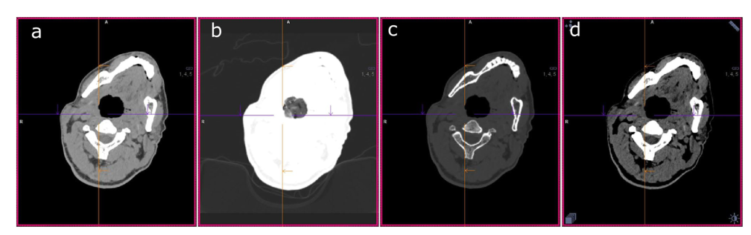

2D axial slices may be converted to 3D volumetric depictions or surface reconstructions.11 CT volume is depicted in voxel units, which are 3-dimensional, single image elements that are similar to pixels in 2-dimensional imaging.14 Each individual voxel is associated with 2 key pieces of information: its location in 3-dimensional space, and its x-ray attention.14 Although voxels are the standard for depicting the volumes of 3D medical images, crime scene analysis and 3D printing often use polygon meshes. Whereas voxels describe the entire 3-dimensional volume of an object, polygons describe the exterior surface shape. Polygons are derived from a set of points on the object surface (which are called vertexes), which are connected by lines to form polygons, or faces (Figure 2).14

Figure 2. Two-dimensional data from a CT scan can be converted to a polygon model that depicts the surface of a 3-dimensional object. The polygon mesh is developed from a set of points (or vertexes), which are distributed over the surface of the object. The points are interconnected by edges, and a group of edges together form a polygon (or face). [Ebert 2021; Licensed under Creative Commons Attribution] https://creativecommons.org/licenses/by/4.0/
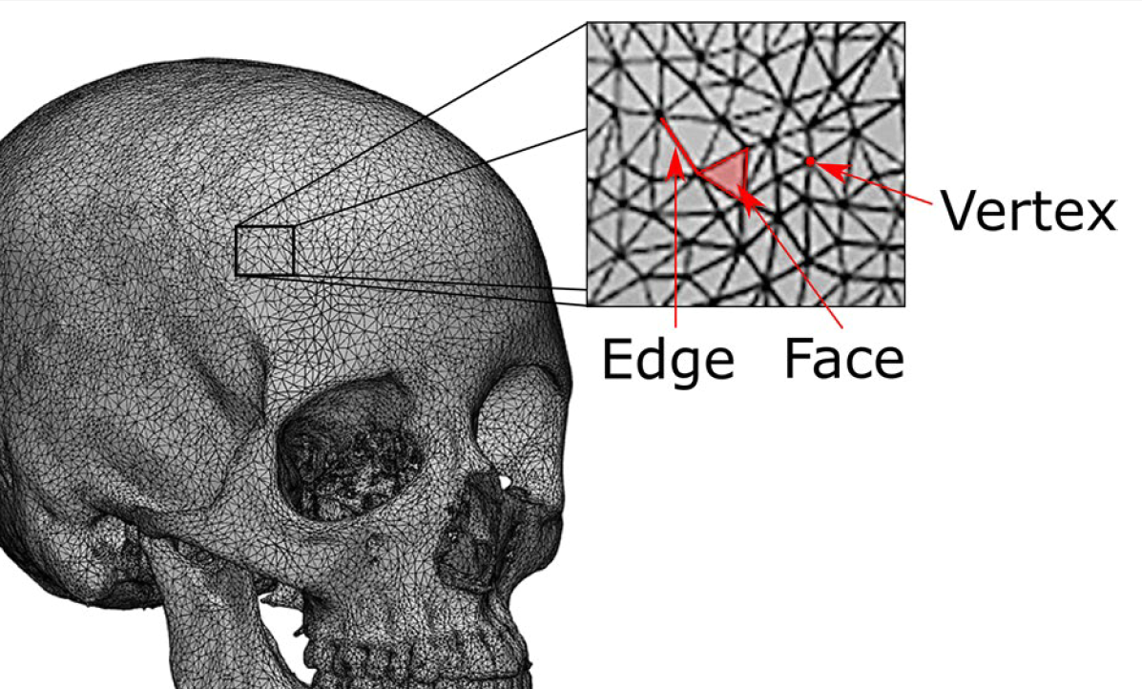

Polygon models are suitable for 3D printing, which is a rapid prototyping technique in which a physical object is created from digital data (see Figure 3).14 A variety of printing technologies are available based on a number of printing materials, including plastics, resins, and metals. Commercial vendors are available for creation of large or complex objects, although data privacy must be considered in these cases. Forensic applications of 3D printing include facial reconstruction, weapon matching, presentation of evidence in court, and classroom education.14

Figure 3. 3D-printed object using data extracted from a CT scan. [Ebert 2021; Licensed under Creative Commons Attribution] https://creativecommons.org/licenses/by/4.0/

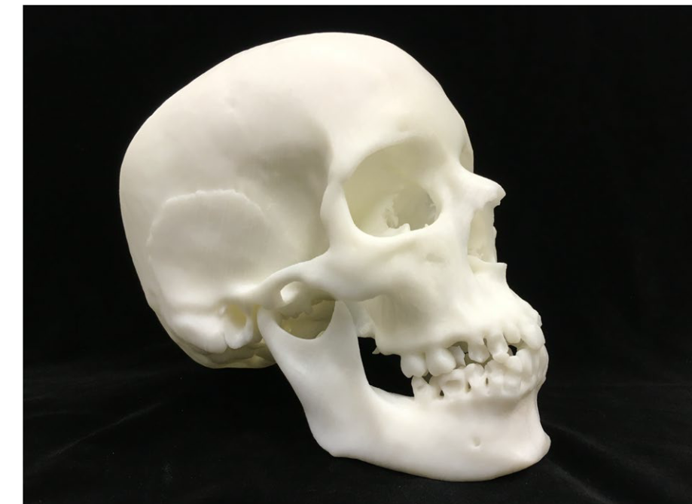

Many advanced imaging modes that are used in clinical CT are also useful in the postmortem setting, including multiplanar reformatting, maximum and minimum intensity projections, segmentation, volume rendering, mixing and layering, and stereoscopic display (see Ebert 2021 for an in-depth discussion of advanced imaging modes in PMCT).14

PMCT offers many potential advantages in comparison with conventional autopsy.12, It can quickly and easily detect common pathologies such as bone fractures and projectiles without damaging the body or body part being examined. Research has shown that PMCT is highly accurate for identifying the cause of death when compared with a traditional autopsy. One study found that PMCT was able to correctly identify the cause of death 100% of the time in cases of suspected unnatural adult death involving a broad range of pathologies, including acute heart failure, burns, intracranial bleeding, gunshot wounds, trauma, strangulation or hanging, and heat shock. Agreement with autopsy was lower in cases involving more subtle soft-tissue pathologies, such as intoxication, pneumonia, or gastrointestinal bleeding. The relatively noninvasive nature of CT reduces the potential for disfigurement of the body, can be important to next of kin for cosmetic or spiritual reasons. The use of a picture archiving and communication system (PACS) facilitates comparison with previous images and simplifies sharing with a radiologist or forensic pathologist. The ability to image remains inside sealed body bags has the potential to reduce physical contact with the remains, which may reduce the risk of pathogen exposure.7 CT images are less graphic than crime scene or autopsy photographs, and may be more acceptable for use in setting such a jury trial.7,10 As in the clinical setting, CT may be combined with contrast agents to better visualize the vascular system, which is difficult to examine in traditional autopsy.15 PMCT may be faster than traditional autopsy, allowing earlier release of the deceased to the undertaker or family members, and also reducing the need for trained staff to perform forensic examinations.7 The use of dual-energy CT can distinguish ferromagnetic from nonferromagnetic objects, which is helpful if the cadaver is to undergo postmortem magnetic resonance imaging.2

Postmortem CT Image Acquisition and Quality
PMCT images must be of the highest quality possible in order to produce credible evidence for criminal and civil cases, and for comparing postmortem images with antemortem images for establishing identity.1 Although the general principles of PMCT are similar to clinical CT, there are important differences. Standard scan protocols established by device vendors or by imaging centers for clinical use may be optimized to prioritize reduced radiation exposure or fast imaging techniques to avoid motion artifacts. These approaches may be less critical in postmortem imaging, where image quality can be increased by higher radiation doses and longer exposure times without concern for radiation exposure to the patient.2 However, although radiation exposure to the patient is less of a concern in the postmortem setting, it is important to recognize that radiation exposure to imaging or forensic personnel remains an important consideration. Normal radiation safety precautions to reduce staff exposure apply in PMCT, including increasing the distance to the x-ray source and use of shielding.

In addition, although some medical imaging is conducted for the specific purposes of use in criminal or civil investigations, it is important to recognize that any medical imaging can potentially become part of a legal investigation. Diagnostic imaging in settings such as childhood physical abuse, physical assault by a spouse or domestic partner, or other types of nonaccidental injury may be considered a forensic examination, even if the radiologic technologist is not aware at the time that the images obtained may ultimately become critical legal evidence.3

Contrast, noise, and spatial resolution
PMCT image quality is influenced by several factors, including image contrast, noise, and spatial resolution.2 Contrast can be defined as the visual depiction of density differences in adjacent tissues. Contrast is determined by the energy of the administered x-ray photons and the type of tissue or material that is being penetrated. Spatial resolution is the ability of the imaging system to distinguish between the smallest and most closely placed elements in an image, and is determined primarily the x-ray tube aperture and detector size. Image noise refers to the appearance of graininess in reconstructed images, which results from random fluctuations in the number of x-ray photons captured by the detectors.2

Adjustments to image acquisition parameters largely affect radiation dose and can have important impacts on contrast, noise, and spatial resolution.2 Because radiation exposure to the patient is not a concern, PMCT makes it possible to optimize acquisition parameters in ways that are not possible in clinical imaging. Tube voltage, which is indicated by the kilovolt peak level (kVp), can affect image contrast. Higher x-ray photon kVp (referred to as x-ray quality) provides greater penetration of dense objects such as bone, but also reduces overall image contrast. In clinical imaging, tube voltage is typically set at 120 kVp, which provides an optimal trade-off of contrast for soft tissues and bones.2 Higher tube voltage (eg, 140 kVp) may be selected for postmortem dental scans, scans involving metallic objects, or exhumed skeletal remains where soft tissue assessment is not required. Lower voltages (eg, 100 kVp) may improve visualization of iodine contrast of vascular structures. Increased tube current, or the amount of radiation delivered, is associated with reduced imaging noise. The total number of x-ray photons delivered is expressed as the tube current (mA) times the scan duration (s), or mAs, and is a measure of x-ray photon quantity.2,19 The ability to image at higher tube current values is one of the main advantages of PMCT. Suggested mAs values for PMCT are 300 mAs for whole body, 500 mAs for thorax/abdomen, and 1000 mAs for head and neck.2

Body Positioning
Most PMCT examinations begin with unenhanced whole-body PMCT. Optimal imaging may require some repositioning of the body. For example, image artifacts and noise when imaging the thoracic and abdominal regions may be reduced by moving the hands and arms above the head. A baseline scan should be obtained before any such repositioning is performed. The ability to reposition the body may be limited in some cases by rigor mortis or tissue damage (eg, from burn injuries). Imaging of the complete body may require pulling or repositioning the body on the CT table, which may be made easier by the use of silicone or glide sprays on the table mattress overlay.2 Adjusting the height of the table to position the body in the center of the gantry is important to achieve the best image quality, as scanning algorithms usually optimize radiation dose for the center of the scanning region. PMCT may sometimes be performed with the cadaver or remains contained within a body bag. Care should be taken to remove any handles or zippers from the scan region to prevent metallic artifacts. A body bag may also be visible in post-processing reconstructions (eg, volume rendering) or may interfere with post-processing reconstructions involving body surface.2

Forensic Radiology Applications: Typical Examinations and Findings

Bone fractures and trauma
One of the primary applications of x-ray images is the clear visualization of bone fractures. Research suggests that PMCT may be more sensitive than traditional autopsy for detecting bony injuries, with the exception of rib fractures, where autopsy may be superior.7 In some cases, an important advantage of PMCT is its ability to detect bone fractures in areas that may not be found in routine autopsy, such as the face, neck, and hands. PMCT may be especially helpful for evaluating fractures in areas that would be difficult or time consuming to access during traditional autopsy, such as the base of the skull.7

PMCT is also useful for examining head trauma and traumatic brain injury (TBI), which is a major cause of death and long-term disability in the US and throughout the world. Common causes of TBI include self-inflicted harm, falls, sports injuries, and motor vehicle accidents.21 TBI events are often associated with complex wound sites that may include soft tissue injuries of the scalp (lacerations, abrasions, and contusions), fracture of the skull, contusions of the brain, epidural hematomas, and intracerebral hemorrhages. The combination of bleeding and shear forces can damage brain cells and result in long-lasting cognitive impairment even when the skull is intact.22 PMCT can be used to identify and examine a number of consequences of TBI, including fractures of the skull and vertebrae, the presence of air embolism cerebral arteries and veins, intracranial bleeding, or bleeding within the eyes (which can occur when there is a fracture of the orbit, and also in cases of “shaken baby” syndrome). Representative PMCT findings in trauma are illustrated in Figure 4.

Figure 4. PMCT findings illustrating fracture and air inside the cranial cavity and peritoneum. (A) Left-side fractures of frontal bone, face, and mandible; (B) right scapula fracture; (C) pneumocephalus underlying left frontal vault fracture; (D) left frontal hemosinus underlying left frontal bone fracture; (E) Right pneumoperitoneum. [K 2023] Licensed under Creative Commons Attribution] https://creativecommons.org/licenses/by/4.0/

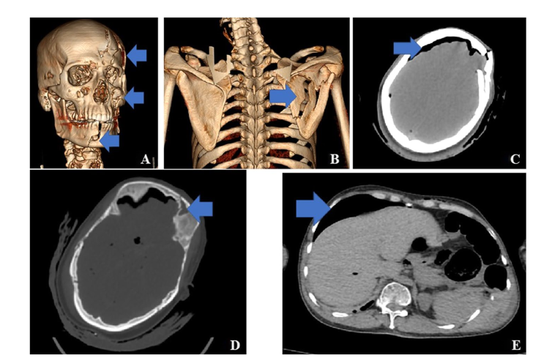

Gunshots/ballistics analysis
CT images, whether postmortem or clinical, provide extensive information about gunshot injuries and ballistics, and used in medicolegal cases.3 Some of the types of information that can be determined from a CT scan include:12
- Distance of the firearm from the body (especially with shotgun wounds)
- Number of shots
- Direction of travel of bullets through the body (penetrating, perforating, tangential)
- Entrance and exit wounds
- Bullet tracks and ricochets
- Bone and soft tissue lesions
- Type of ammunition
- Number of projectiles
- Shape, fragmentation, and expansion of projectiles
- Projectile composition, dimensions, and bullet caliber

Gunshot wounds often appear as linear defects that may contain gas and fragments of metal or bone. In the brain or lungs, bullet wounds are typically characterized by hemorrhage and gas bubbles; a linear track may or may not be present. Identification of the bullet and bullet fragments also facilitates removal for ballistic analysis.

Identifying and overcoming metal CT artifacts can be especially important in ballistic analysis, where the presence of metal fragments may interfere with the ability to adequately image surrounding tissues. Metallic items such as bullets or pellets produce very high x-ray attenuation and are susceptible to several types of CT artifacts, including beam hardening, photon scattering, and photon starvation. Together, these effects can greatly increase image noise, create blind spots around metal items, cause streaking artifacts, and alter the representation of size or shape.12 Metal artifacts may be reduced by dual-energy CT, which limits the effects of beam hardening but does not overcome photon starvation.

Other foreign bodies
CT or other radiographic techniques may be used to detect smuggled packages in body cavities or to identify ingested materials or other foreign bodies (eg, knife blades, needles). Smuggled materials may be detected incidentally during clinical examinations of patients who have been assaulted or injured in motor vehicle accidents.3 3D modeling of an injury site has been used to identify weapon types or even to match an injury to a specific weapon.11

Image-guided Biopsy
PMCT imagery is often used to guide biopsy or sample collection, such as urine collection from the bladder, blood from the heart and large veins, or fluid from pancreatic or hepatic cysts. The ability to obtain these samples without dissecting the surrounding tissues is especially useful when the samples are to be used to obtain microbiologic cultures.15

Bleeding sites/sources
Hemoperitoneum (bleeding within the peritoneal space) can occur as a result of a number of causes, including trauma, as a complication of surgery or resuscitation, or spontaneously. In cases of trauma, the bleeding may originate from a number of sources, including blood vessels, bladder, bowels, spleen, liver, or others. PMCT has been used to correctly identify the bleeding source in cases of abdominal bleeding, and to identify other characteristic signs of hemoperitoneum, such as pooling of blood around organs (typically the liver, kidney, or spleen), and abnormal gas distribution with disruption of parenchymal tissues.25

Identification of human remains/victim identification
Identifying humans or human remains has long been a primary application of forensic radiography.3 These techniques rely on comparison of postmortem and antemortem images, so it is essential that positioning and acquisition techniques are similar enough to standard medical imaging to permit accurate comparison.3 Any unique skeletal features can be used for identification, including healed fractures, skeletal changes due to degenerative disease, orthopedic hardware, or surgically implanted prostheses.15 Dental findings are often important in identifying individuals. Teeth may be the only surviving recognizable tissue if the cadaver is extensively burned or decomposed, and the combination of tooth shape and restoration is often sufficient to uniquely identify an individual.15 CT can also provide information about the victim’s age, sex, stature, personal effects, and other anatomical characteristics, and it can provide clues as to trauma or pathological conditions that may have contributed to the person’s death. 3D facial reconstructions may also be useful in victim identification.4 Mobile multidetector CT (MDCT) units have been deployed to assist with on-site processing and identification of remains at mass casualty incidents, which may vary from motor vehicle accidents to natural disasters or acts of terrorism. In these cases, radiographers may help to identify and inventory body parts, personal effects, or distinguishing features that may be useful in victim identification.3 Single-body or multiple fragment bags may be scanned onsite without opening if necessary.

Gas Deposits and Body Decomposition
Due to its ability to differentiate materials of different densities, CT is effective for distinguishing bone, fat, water, and gases.7 It is useful for identifying ectopic air or gas deposits (gas deposits outside their usual location in the aerodigestive tract) which might be associated with conditions such as pneumothorax, pneumoperitoneum, or gas embolism. These abnormal free gas accumulations often go undetected in a traditional autopsy.7 The extent of decomposition can be estimated from PMCT evidence, including the presence of gas deposits, body swelling, eye and tongue protrusion, expulsion of body fluids, and liquification of fat.15,

Microfractures
Strangulation is a common cause of homicide, and is also seen in cases of suicide and accidental death. It can be challenging to detect using traditional autopsy, especially when there are no clear bruises, other surface wounds, or underlying soft tissue injury. In addition, small laryngeal fractures can also occur from a variety of other causes, such as motor vehicle accidents, sports injuries, or falls. Therefore, accurately characterizing damage to larynx is often a critical medicolegal issue. Histologic examination of laryngeal tissue is time-consuming, costly, and technically challenging. Micro-CT is a high-resolution CT technique that provides a 3D, high-resolution reconstruction with a resolution of 1 micrometer or less.27 This level of detail, which is similar to that of a microscope, can reveal microscopic lesions without physical dissection of the specimen.13 This approach can provide detailed analysis of subtle lesions of bone and cartilage provides, and has been used to identify microfractures of the laryngeal skeleton associated with strangulation (Figure 5).27

Figure 5. Typical discontinuities of laryngeal bones identified in a study of postmortem micro-CT in strangulation victims versus control postmortem control subjects. (a) Discontinuity of the inferior thyroid margin, observed in a control subject (arrow). (b) Fracture at the base of the superior thyroid horns, in a forensic case (arrow). [Baier 2020] Licensed under Creative Commons Attribution. https://creativecommons.org/licenses/by/4.0/

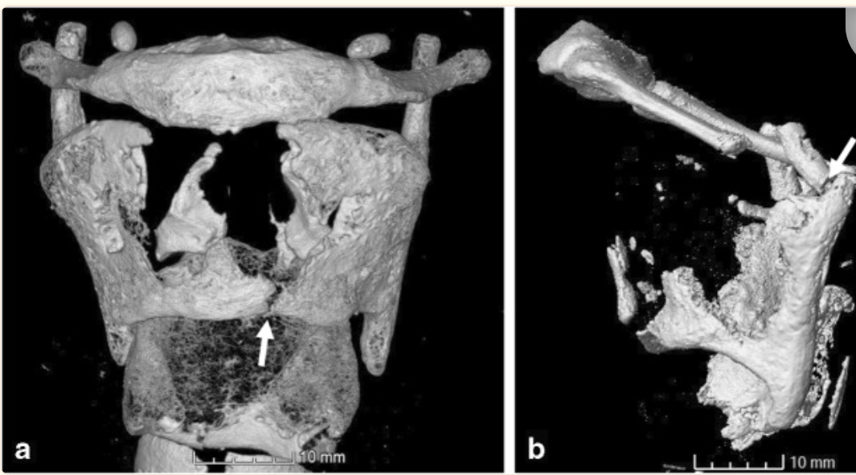

Cardiovascular analysis
Postmortem CT angiography (PMCTA) techniques can reveal cardiovascular changes such as trauma or sudden cardiac death when decomposition is still in the early stages.20 Infusing a CT contrast agent into the vascular system using a mechanical pump allows detailed visualization of the vascular system and vascular lesions without dissection of the cadaver. These techniques can be used to assess pathology involving the heart and coronary arteries, systemic circulation, airway/lung, and pulmonary artery, as well as the abdomen, head, and extremeties.7,13, Infusion of contrast through the femoral artery and vein is used to visualize the entire arterial tree, including the aorta, intracranial, and coronary arteries.15 It is also possible to target specific regions, such as the heart or lungs. It may be necessary to turn the cadaver several times to dislodge postmortem clots that obstruct the flow of contrast through the blood vessels.20 This technique has been used in the assessment of patients with sudden cardiac death, where it can has been used to demonstrate a number of pathologic conditions involving the coronary arteries, vascular obstruction, or hemorrhage. Abnormal pooling of the contrast agent outside the vascular system can also identify bleeding sites or other vascular lesions, which can be difficult to identify in traditional autopsy. For example, postmortem infusion of contrast in a car accident victim demonstrated presence of contrast within the pericardial sac, indicating a fatal aortic rupture. It is also superior to conventional CT for the identification of pulmonary embolism, which is often difficult to detect without contrast.13
A variety of contrast agents are available for PMCT, including water-based and oil-based solutions, or air. A potential disadvantage of water-based contrast agents is that vascular permeability increases after death, and the contrast may leak from the blood vessels into the surrounding tissues.28 The infusion of contrast agents in PMCTA may interfere with toxicologic analysis of blood and urine samples. Therefore, samples for toxicology screening should be collected before PMCTA is performed.

Limitations of PMCT
PMCT is also associated with potential limitations. Although CT is very effective for identifying bone lesions and metallic foreign bodies, it is generally less sensitive for the detection of some common pathologies that are encountered during autopsy, including tissue decomposition, pulmonary embolism, visceral and soft-tissue lesions, and some cardiac pathologies. It is also less useful for identification of conditions such as sepsis, metabolic disorders, intoxication, meningitis or other subtle changes to the central nervous system, or pancreatitis.7,20 In some cases, PMCT may identify certain pathologic findings, but not the underlying causes. For example, PMCT has high sensitivity for ectopic air accumulation but low sensitivity for soft tissue damage, and may therefore detect a pneumoperitoneum but not the underlying perforation. However, this information that ectopic air is present may still provide useful guidance to the pathologist.7 In addition, physiologic changes that occur postmortem mean that the CT appearance of many body structures may appear different than on a medical or antemortem scan.7 Because of postmortem changes to the blood vessels, administering IV contrast agents may be more difficult or even impossible, which may limit the ability to conduct some types of analyses.12 The equipment is more costly and complex than conventional radiography and requires more specialized operator training.11 Dual-energy devices can overcome some of the limitations of PMCT, offering better soft-tissue resolution and reduction of metallic artifacts. However, they are also more expensive than conventional CT, both to purchase and to maintain.

Forensic Radiography Training and Careers
Forensic radiography is not used as widely in the US as it is in many other parts of the world, and only a small number of medical examiner officers routinely use PMCT. There is considerable variability in the medical examiner system from state to state, and pathology services might be provided by a variety of state, county, or city government services or by private contractors. There is no single “forensic radiography” career in which a technologist focuses exclusively on forensic imaging. Any radiographer may be called upon to perform imaging that has medicolegal implications, either on living patients or on cadavers.6 Forensic radiography work settings can be varied than the clinical settings that are typical of RT practice. Postmortem radiography assessments may include evaluation of human remains at a medical examiner or coroner office, at a funeral home, in a clinical setting after hours, or even at mass casualty sites.3

Most people who conduct forensic radiography examinations are trained on the job, and there is little standardization of forensic imaging training. Although licensing and training may be less of a concern in the postmortem setting than in clinical imaging, there are still several reasons to ensure that personnel are adequately trained.3 Forensic radiography often involves comparing postmortem images with one another or with antemortem images, which means that all images must be obtained as consistently as possible. Images must be of high quality, both for comparing with previous imaging and to provide convincing evidence if used in court. The person conducting the examination also must be able to evaluate and ensure image quality. In addition, although patient radiation safety is not a concern for postmortem radiography, it is still important to be able to appropriately manage radiation exposure for the operator. Contemporary forensic radiography technology has increasingly relied on complex technology such as CT or mobile CT scanners, which are technologically complex and require more training to operate. Finally, radiologic technologists provide a high level of expertise and training about radiation exposure monitoring, mitigation, and reporting. Radiologic technologists understand how the radiation beam travels when positioning a C-arm, as well as requirements and techniques for effective radiation shielding.3

Although there are also no generally accepted standards or guidelines regarding PMCT in the US, the American Society of Radiologic Technologists (ASRT) has developed an educational framework that outlines the key information needed by the 3 main groups of forensic imaging professionals (radiologic technologists, limited x-ray machine operators, and forensic assistants).1 This framework was published in 2010 but has not been recently updated.

Conclusions
Over the last decade, PMCT and postmortem CT angiography have emerged as important sources of information that go beyond traditional autopsy or conventional radiography in forensic examination. PMCT is relatively rapid, noninvasive, and highly accurate for identifying cause of death. Research suggests that PMCT may be more sensitive than traditional autopsy for detecting bony injuries, with the exception of rib fractures, where autopsy may be superior. Other applications of PMCT include evaluations of gunshot wounds/ballistics, foreign bodies, image-guided biopsy, internal bleeding, gas deposits/body decomposition, microfractures, and cardiovascular pathology. CT is generally less sensitive for the detection of some common pathologies that are encountered during autopsy, including tissue decomposition, pulmonary embolism, visceral and soft-tissue lesions, and some cardiac pathologies. PMCT images must be of the highest quality possible in order to produce credible evidence for criminal and civil cases, and for comparing postmortem images with antemortem images for establishing identity.

American Society of Radiologic Technologists. Forensic Radiography Educational Framework. 2010. Accessed June 29, 2023. https://www.asrt.org/docs/default-source/educators/ed_forensicsfrmwrkedtd_020810.pdf
Gascho D, Thali MJ, Niemann T. Post-mortem computed tomography: Technical principles and recommended parameter settings for high-resolution imaging. Med Sci Law. 2018;Jan 58(1):70-82.
Kudlas M, Odle T, Kisner L. The state of forensic radiography in the United States. ASRT. March 25, 2010. Accessed June 29, 2023. https://www.asrt.org/docs/default-source/research/whitepapers/forensic_radiography_white_paperfin.pdf?sfvrsn=21dc3b81_10
Doyle E, et al. IAFR Guidelines for best practice: Principles for radiographers and imaging practitioners providing forensic imaging services. Forensic Imaging. 22:200400.
Zhang M. Forensic imaging: a powerful tool in modern forensic investigation. Forensic Sci Res. 2022;Mar 7;7(3):385-392.
Jones R. Forensic Radiography – The Dark Side of Radiology. The Radiologic Technologist. May 24, 2019. Accessed June 29, 2023. https://theradiologictechnologist.com/what-is-forensic-radiography-the-dark-side-of-radiography/
Mercala E, Benbow EW. Autopsy by Imaging: The Last 10 Years. Forensic Sci. 2022;2;696–714.
Menezes RG, Monteiro FN. Forensic Autopsy. 2022 Sep 5. In: StatPearls [Internet]. Treasure Island (FL): StatPearls Publishing; 2023 Jan.
Centers for Disease Control and Prevention. Investigations and Autopsies. February 28, 2023. Accessed June 28, 2023. https://www.cdc.gov/phlp/publications/coroner/investigations.html
Daly B. Forensic Radiology: An Exciting and Developing Field That Needs More Trained Radiologists. Acad Radiol. 2019;26(6):831-832.
Carew, RM; Errickson, D. Imaging in forensic science: Five years on. Journal of Forensic Radiology and Imaging. 2019;16:24-33.
Blum A, Kolopp M, Teixeira PG, Stroud T, Noirtin P, Coudane H, Martrille L. Synergistic Role of Newer Techniques for Forensic and Postmortem CT Examinations. AJR Am J Roentgenol. 2018;211(1):3-10.
Cafarelli FP, Grilli G, Zizzo G, et al. Postmortem Imaging: An Update. Semin Ultrasound CT MR. 2019;40(1):86-93.
Ebert LC, Franckenberg S, Sieberth T, Schweitzer W, Thali M, Ford J, Decker S. A review of visualization techniques of post-mortem computed tomography data for forensic death investigations. Int J Legal Med. 2021; 135(5):1855-1867.
Elfiritz JM, Nolte KB, Hatch GM, Adolphi NL, Gerrard C. Forensic radiology. In: Pathobiology of Human Disease: A Dynamic Encyclopedia of Disease Mechanisms http://dx.doi.org/10.1016/B978-0-12-386456-7.06706-X.
DenOtter TD, Schubert J. Hounsfield Unit.. In: StatPearls [Internet]. Treasure Island (FL): StatPearls Publishing; 2023 Jan [Updated 2023 Mar 6].
Norberti N, Tonelli P, Giaconi C, Nardi C, Focardi M, Nesi G, Miele V, Colagrande S. State of the art in post-mortem computed tomography: a review of current literature. Virchows Arch. 2019;475(2):139-150.
Hueck U, Muggenthaler H, Hubig M, et al. Forensic postmortem computed tomography in suspected unnatural adult deaths. Eur J Radiol. 2020;132:109297.
Sy E, Samboju V, Mukhdomi T. X-ray Image Production Procedures. Updated 2022 Oct 17. In: StatPearls [Internet]. Treasure Island (FL): StatPearls Publishing; 2023 Jan.
Decker SJ, Braileanu M, Dey C, Lenchik L, Pickup M, Powell J, Tucker M, Probyn L. Forensic Radiology: A Primer. Acad Radiol. 2019;26(6):820-830.
Centers for Disease Control and Prevention, National Center for Injury Prevention and Control. Report to Congress on traumatic brain injury in the United States: Epidemiology and rehabilitation. Atlanta (GA): Centers for Disease Control and Prevention; 2015.
Bertozzi G, Maglietta F, Sessa F, et al. Traumatic Brain Injury: A Forensic Approach: A Literature Review. Curr Neuropharmacol. 2020;18(6):538-550.
K KVR, Khan A, Yadav A, et al. Comparative study of postmortem computed tomography (PMCT) against traditional forensic autopsy findings in fatal road traffic accidents — a pilot analysis. Egypt J Forensic Sci. 2023;13: 21.
Levy AD. Postmortem Radiology and Imaging. Medscape. August 5, 2019. Accessed June 29, 2023. https://emedicine.medscape.com/article/1785023-overview
Chatzaraki V, Thali MJ, Ampanozi G. Diagnostic accuracy of postmortem computed tomography for bleeding source determination in cases with hemoperitoneum. Int J Legal Med. 2021;;135(2):593-603.
Cartocci G, Santurro A, Neri M, Zaccagna F, Catalano C, La Russa R, Turillazzi E, Panebianco V, Frati P, Fineschi V. Post-mortem computed tomography (PMCT) radiological findings and assessment in advanced decomposed bodies. Radiol Med. 2019;124(10):1018-1027.
Baier W, Burnett BA, Payne M, Warnett JM, Williams MA. Using micro-computed tomography to examine the larynx in cases of suspected strangulation-a comparison of case findings and control images. Int J Legal Med. 2020;134(4):1441-1450.
Lee H, Lee S, Cha JG, Baek T, Yang KM. Postmortem Computed Tomography and Computed Tomography Angiography: Cardiothoracic Imaging Applications in Forensic Medicine. J Thorac Imaging. 2019;34(5):286-298.
Pearson D. Dual-energy CT: Is it what the doctor ordered for the cost-conscious community hospital? Radiology Business. Accessed June 29, 2023. https://radiologybusiness.com/sponsored/1081/hitachi-healthcare-americas/topics/healthcare-management/healthcare-economics/dual.
Kaplan DA. Postmortem Imaging: The Next Radiology Subspecialty? Society of Nuclear Medicine and Medical Imaging. March 10, 2016. Accessed June 29, 2023. https://www.diagnosticimaging.com/view/postmortem-imaging-next-radiology-subspecialty.

